Id=1
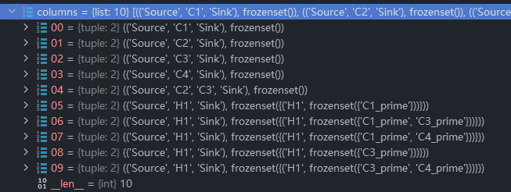
Id=2
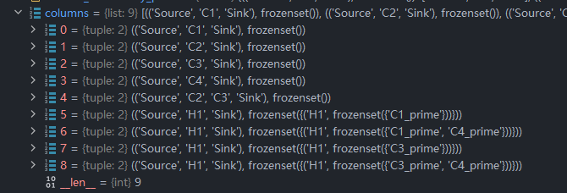
Id=3
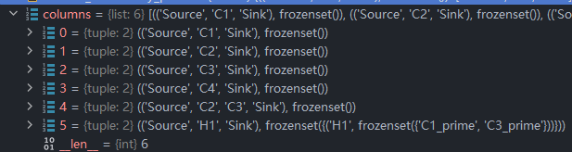
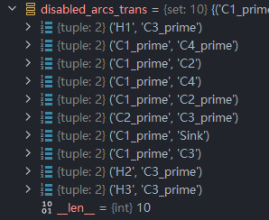
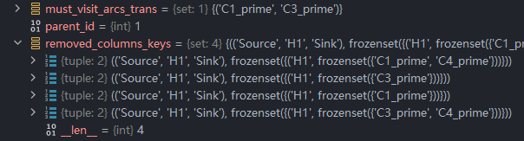

num_customers = 8
num_hubs = 1
num_trucks = 8
num_drones_per_truck = 3
cost = 6078
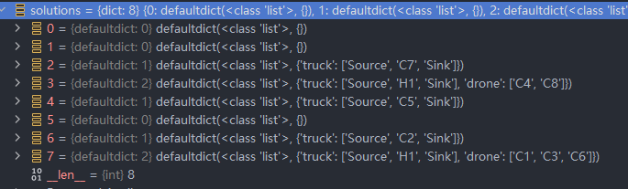

BP solution: cost=6080 true
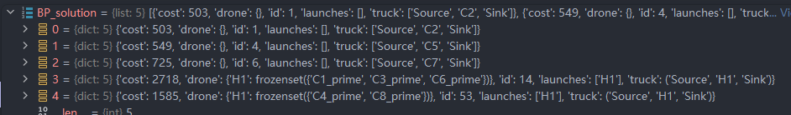

num_customers = 10
num_hubs = 3
num_trucks = 5
num_drones_per_truck = 3

Full model cost = 11549
